Springboard Software Engineering Track
Capstone 1 Formal Proposal by
Larry Volz:

RememberTogether (Virtual-Memorials.net)

Website Goal
The purpose of this website is to empower grieving families to make beautiful and persistent memorial pages for loved ones who have passed away.

Target Demographic
This website is intended for two demographics: a business demographic and an end-user demographic.

The B2B demographic is funeral directors. This site will be made so that they can either refer families to the site as an added value to their services or even “white wrapper it” with their own marketing information.

The end users are families and friends of the people that they want to memorialize.

Data Used

Within the on-site app the data gathered will be as follows:
- Sign-in information for the moderator. That will usually be a close loved one who writes and saves the “create memorial page”.
- Information regarding the loved one who has passed on. This will be provided by the moderator as well as family and friends who will be allowed to post memories on the site.
- Information on memorial services including where and when they will be held.

Regarding the API this app will be using data for one or more of the following purposes:
- Sign-on information to Facebook for easy sign-in tho this app and/or uploading of pictures/memories of the departed
- Connectivity data needed to interface with a flower company so that visitors may buy flowers online through an affiliate link on the site
- Connectivity data needed to interface with Zoom or other web-streaming services in order for funeral directors to share the funeral service with remote users

Database Schema

The following is the database schema planned (subject to change)::
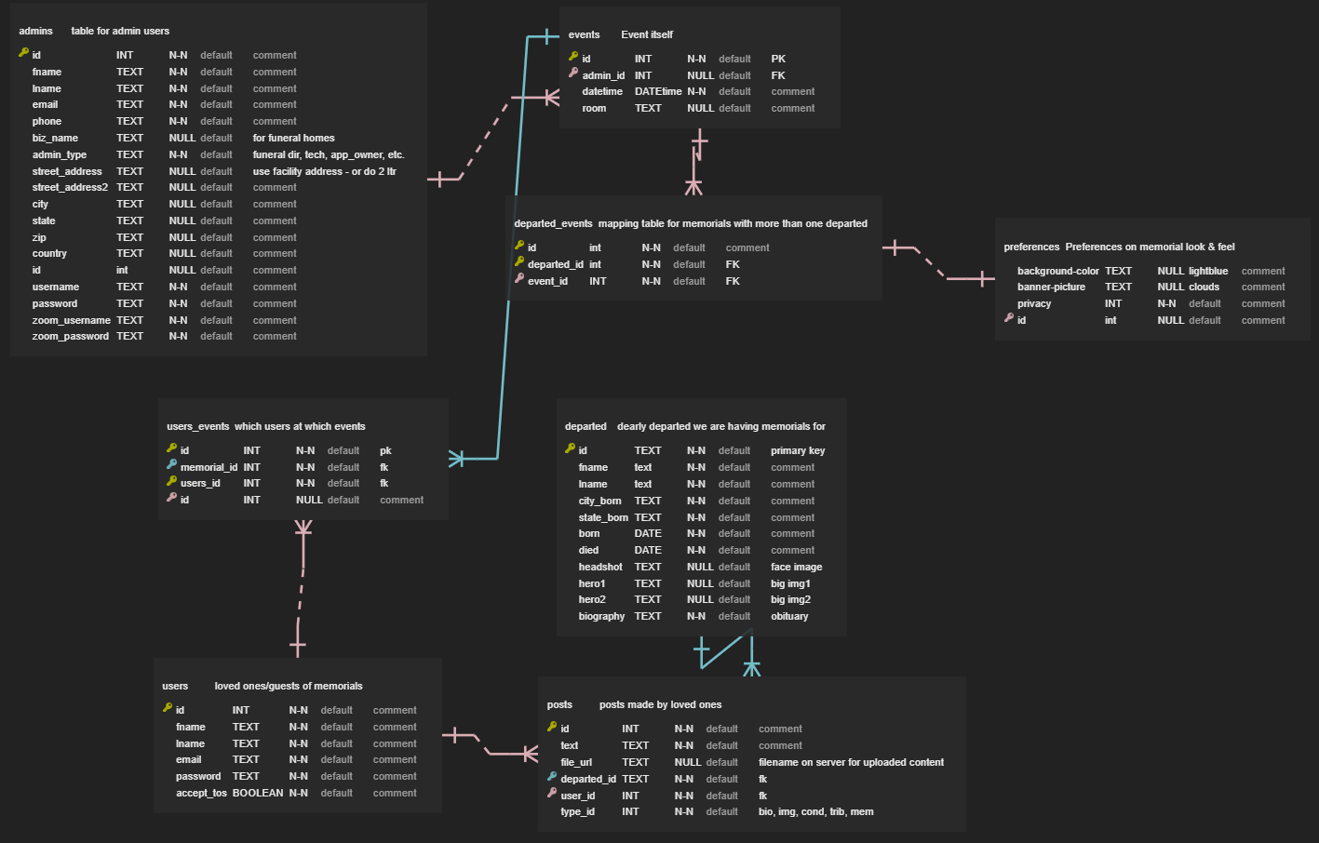

Possible Issues with API
One issue worth considering in advance is the importance of keeping the key where it cannot be seen in Chrome tools or used for cross-site security issues. It will be kept on the back-end to prevent that.

Another is that costs could be incurred by one or the other. More research needs to be done in that area.

A third is that if I do both there is the concern that they might interfere with each other.

Information Security

A lot of the information is of a private nature and needs to be kept secure for the comfort and well-being of the users. However the more practical concern is that of security around the user's flower purchases. It needs to ensure that credit card numbers and passwords cannot be stolen using Bcrypt or similar.

User Flow

Below is a preliminary use case diagram of what the user flow will look like.
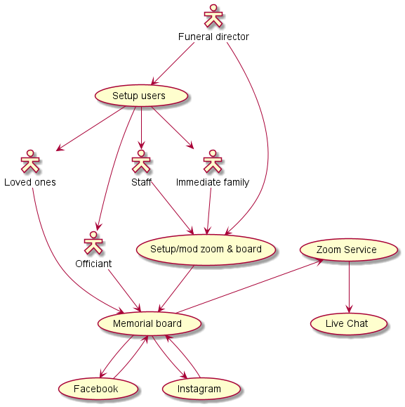

Stretch Goals
The stretch goals I have set for this project include some or all of the following:
- Using jQuery-UI to create an auto-complete field for looking up the names of the departed which is filled from the database. This will requiret front-to-back-end communication using JSON and Axios
- The capability of uploading images and saving them to the database for both the memorial (obituary) main page and for sharing memories (posts).
- The capability of uploading videos
- Integration with more than one API

